|  |  |  |
| --- | --- | --- |
| Quantum User Guide | 2012 | |
| Quantum Automatic Trading System is an intelligent system which helps investors to maximize profits and minimize risks during their trading. | |  |

Quantum 2012 User Guide

Table of Contents

Quantum 2012 User Guide 2

Table of Contents 2

Table of Figures 5

1 Introduction: Why Quantum. 6

2 Investment Cases 6

2.1 You have already known what stock you want to trade today 6

2.2 You have no idea what to trade today 9

3 Launch Quantum 11

3.1 Login window 11

Figure 8: Login window 11

3.2 Configuration window 11

Figure 9: Configuration window 11

3.3 Main Window 12

3.4 Opening Chart 12

4 Account Setting 13

4.1 Creating Portfolio 13

4.2 Creating Watch List 14

5 Working with Quantum charts 15

5.1 Zoom In 15

5.2 Zoom Out 15

5.3 Periodicity 15

5.4 Chart Styles 15

5.5 Chart Property 15

5.6 Indicators 15

6 Decision making with Quantum Strategies 16

6.1 Quantum Strategy Overview 16

6.1.1 What is a Quantum Strategy (QS)? 16

6.1.2 How does a Quantum Strategy work ? 16

6.1.3 Quantum Strategy parameters 17

7 Avoiding investment risks with Quantum Back Testing 17

7.1 What is Quantum Back testing ? 17

7.2 Why should we back-test ? 17

7.3 How to use BackTesting 17

7.4 Estimation of strategies 19

8 Finding the best automatic expert with Quantum Strategy ranking 19

8.1 What is Quantum Strategy Ranking 19

8.2 Strategy Ranking result 20

9 Effective way to build a portfolio with Quantum Stock ranking 21

9.1 What is stock ranking? 21

9.2 Stock Ranking result 22

10 Analyze stocks from scratch with Quantum Technical Indicators 22

10.1 Indicator parameters 23

10.2 Indicator chart 24

11 Alerts for preference stocks 24

12 Portfolio Management 25

13 Conclusion 25

14 Appendix 1: Frequent Asked Question 26

14.1 Connection problems 26

14.2 What is the performance of Quantum? 26

14.3 Can I chose a moment to buy or sell stock ? 26

14.4 Can I find a good stock to trade ? 26

14.5 How can I find a stock with Buy decision? 26

15 Appendix 2: Glossary 26

16 Appendix 3: Quantum Strategy Explanation 27

16.1 Trending Category 27

16.2 High Frequency Trading category 28

16.3 Others 31

17 Appendix 3: Quantum ranking 31

17.1 Buy Signal Category 31

17.2 Sell Signal Category 31

17.3 Up Trend Category 31

17.4 Down Trend Category 32

17.5 Other category 32

18 Appendix 4: Quantum technical indicators 32

18.1 Trending Indicators Category 32

18.1.1 Simple Moving Average 32

18.1.2 Exponential Moving Average 33

18.1.3 Weighted Moving Average 34

18.1.4 Average Directional Index 34

18.1.5 Bollinger Bands 34

18.1.6 Parabolic SAR 35

18.1.7 Average True Range 36

18.1.8 Aroon 36

18.1.9 Commodity Channel Index 36

18.2 Oscilators Category 36

18.2.1 Relative Strength Index 36

18.2.2 Moving Average Convergence/Divergence 36

18.2.3 Average Directional Index, Plus Directional Index, Minus Directional Index 36

18.2.4 Stochastic RSI 36

18.2.5 Fast Stochastic 37

18.2.6 Accumulation/Distribution Oscillator 37

18.2.7 Aroon Oscillator 37

18.2.8 Chande Momentum 37

18.3 Volume 37

18.3.1 Accumulation/Distribution 37

18.4 Market 37

18.5 Customized 37

18.5.1 Balance of Power 37

18.5.2 Linear Regression 37

# Table of Figures

Figure 1: Login window 6

Figure 2: Main interface of Quantum 7

Figure 3: Open SSI’s chart 7

Figure 4: Selecting Quantum strategy 8

Figure 5: Stock ranking window 9

Figure 6: Stock ranking result 10

Figure 7: Add stock to Watchlist 10

Figure 8: Login window 11

Figure 9: Configuration window 11

Figure 10: Main interface of Quantum 12

Figure 11: Opening chart 12

Figure 12: Account setting 13

Figure 13: Portfolio creation 13

Figure 14: Watch list customization 14

Figure 15: Stock chart 15

Figure 16: Quantum strategy 16

Figure 17: Back testing functionality 18

Figure 18: Back testing result 18

Figure 19: Back testing result 19

Figure 20: Quantum strategy ranking 20

Figure 21: Quantum strategy ranking result 20

Figure 22: Stock ranking 21

Figure 23: Stock ranking result 22

Figure 24: Choosing indicators 23

Figure 25: Indicator parameter window 23

Figure 26: Chart with MACD indicator 24

Figure 27: Alert window 24

Figure 28: Portfolio window 25

Figure 29: Order window 25

# Introduction: Why Quantum.

With more than 700 stocks in Vietnam Stock Exchange, it is hard task for portfolio manager to manage the pools of interested stocks. Moreover, how to maximize the profit of the portfolio and to avoid risks are the questions that can be headache for portfolio manager.

Quatum 2012 is a high effective expert system, which provide portfolio managers capacities to minimize risks and maximize profits. The Quantum’s user take advange of built-in Strategy to evaluate stocks, forex, gold to find out the best time to take action.

Quantum features include:

* Automatic Trading Strategies System helps investors to find automatically Buy/Sell decision;
* Stock Ranking system helps to find the best stocks for trading;
* Strategy Ranking helps to select the best-fit automatic trading strategy;
* Backtesting helps to evaluate the performance of a stock when following a strategy.

This document is organized in 10 sections. The second section will introduce the investment process when using the Quantum software. The third section presents how to launch the system.

# Investment Cases

We describe the following investment case to guide user quick utilization of Quantum system.

## You have already known what stock you want to trade today

Suppose you want to trade SSI, Saigon Securities Company. Within 3-5 steps and less than 1 minutes you can know what to do with your prefer stock and trade it successfully.

**Step 1**: Launch Quantum (refer to Section 3, Launch Quantum)

Click on the icon of the application, you will see the login window. Enter your login and password provided by HQ Corporation. In case you are behind the proxy, chose Configuration and set Proxy as Default.

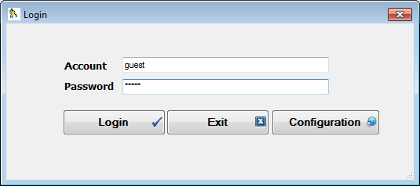

Figure : Login window

The Main Window will be shown like following.

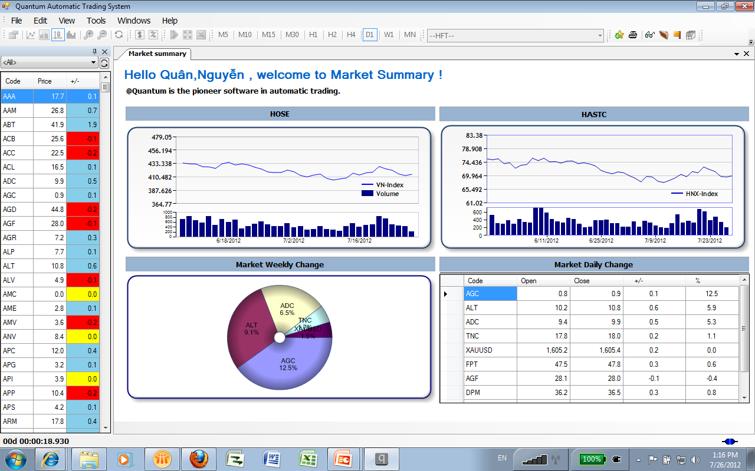

Figure : Main interface of Quantum

Normally, you will see two parts: the Watch List (on the left side) and the Market Summary (main window).

***Note*** *: In some case, in your first login you cannot see the Watch List. So go to View -> Market Watch. The watch list will be shown.*

**Step 2**: Select SSI in the Watch List and open it (refer to Section 5,Working with Quantum charts).

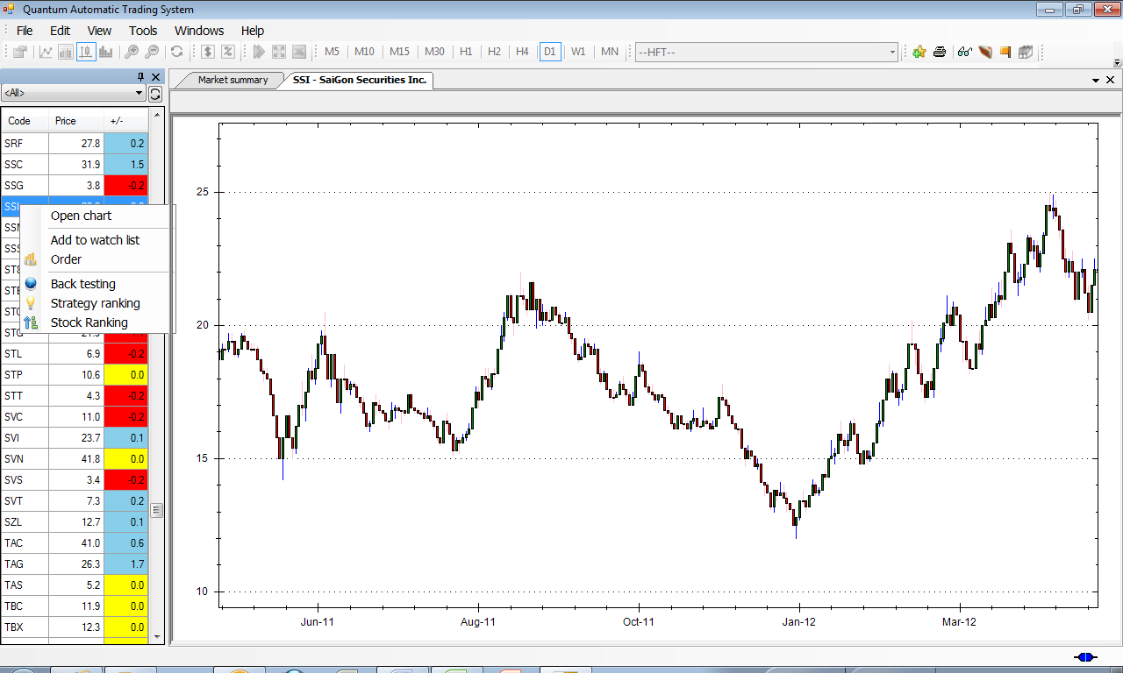

Figure : Open SSI’s chart

**Step 3**: Chose a Quantum strategy to know it is time for Buy or Sell SSI stocks (refer to section 6, Decision making with Quantum Strategies).

There are many built-in strategies. Firstly, choose one of the following to see the result of Quantum decision.

* Two Simple Moving Average Waves compared with Price
* Hybrid SAR-EMA
* Keltner-Bollinger-EMA
* Basic MACD and Two SMA cut

You can see then

* The Transaction Window to show the past transactions and the decision making in the bottom-left window. In the detail, it calculates the profit/loss for each transaction.
* Profit Graph Window: to show the profit/loss of the strategy during a specific period.

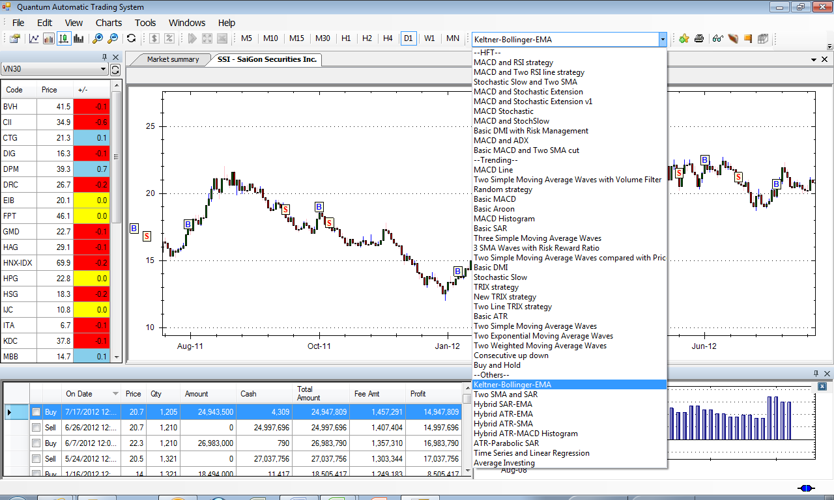

**Quantum Strategy**

Figure : Selecting Quantum strategy

**Step 4**: You can make your decision based on the result of Quantum strategy.

* If there is a BUY signal for today, Quantum expects that stock will rise up in the near future, and you should buy it today;
* If there is a SELL signal for today, Quantum expects that stock will decrease in the near future, and you should sell it today;
* If there is a BUY signal some days before, Quantum expects that stock will rise up in the near future. You should wait as the stock can inverse the trend.
* If there is a SELL signal some days before, Quantum expects that stock will continue to drop up in the near future. You should wait until the stock inverse the trend.

## You have no idea what to trade today

You use Stock Ranking to find Buy/Sell idea and add to your Watch list (see Section 9, Effective way to build a portfolio with Quantum Stock ranking).

**Step 1**: Go to Tools -> Stock Ranking. There is a list of screening strategy that you can choose. They are in five categories:

* finding stocks with Buy signals,
* finding stocks with Sell signals
* finding stocks in up trend
* finding stocks in down trend
* other category: finding stocks having specific criteria (about price, volume, strength, indicators..)

**Step 2**: Choose ranking strategy.

You can decide to do the ranking for all stocks or a list. Choose your preferred list in Code list.

For example, choose the following six stock ranking strategies and the list VN30.

* Buy signal category: MACD and Two SMA Buy Signal
* Sell signal category: MACD and Two SMA Sell Signal
* Up trend category: MACD and Two SMA Up Trend
* Down trend category: MACD and Two SMA Down Trend
* other category: Stocks near support and Stocks near resistance.

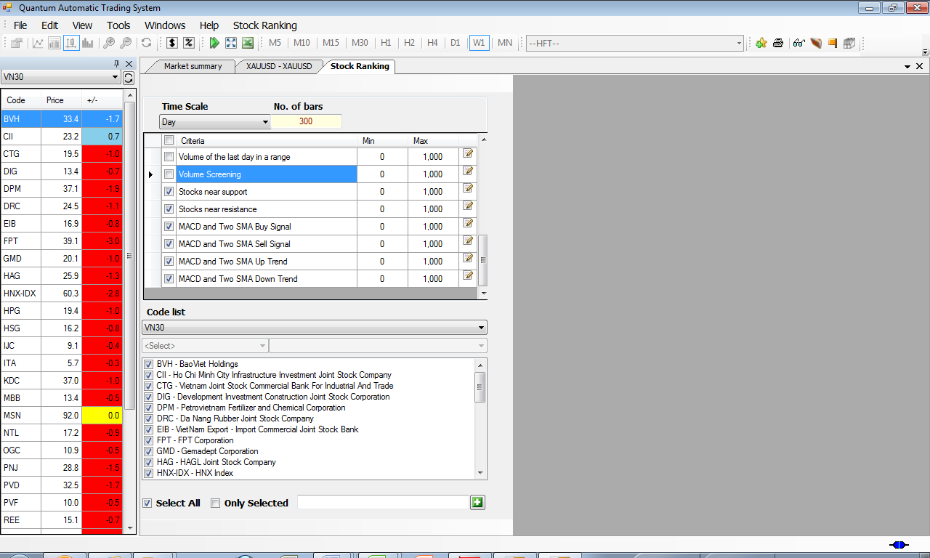

Figure : Stock ranking window

**Step 3**: Get the result. The stocks shown in the grid are potential ones to add on your own watch list.

In the following result, the content of the grid show the price of the stock. The one has value is the one satisfying the condition of the ranking.

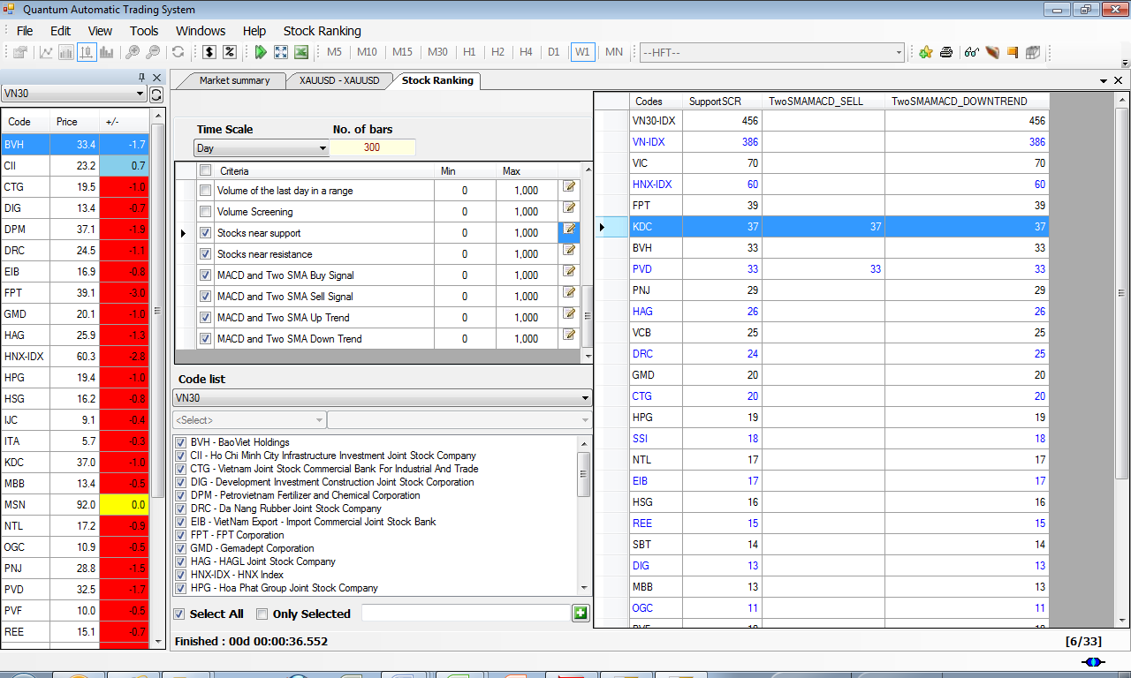

Figure : Stock ranking result

**Step 4:** Add to watch list

Right click on the grid to add a stock into a watch list. You can then see that stock on the watch list in the left hand side.

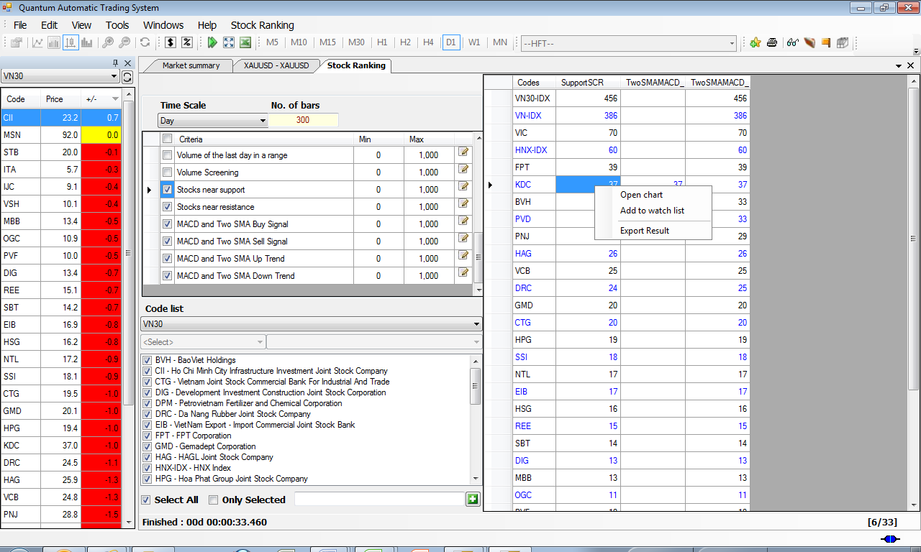

Figure : Add stock to Watchlist

# Launch Quantum

Click on Quantum icon on Desktop, or go to Start menu. You will see the splash window before going to the login window.

## Login window

Quantum system checks the account information before entering the system. Enter your account name and password, which have been provided before.



Figure : Login window

In some situation, when your computer is behind a proxy, you need to configure your computer. Click on Configuration button.

## Configuration window

Configuration window is used when there are a proxy behind the computer. Normally, we can choose the Proxy by Default.

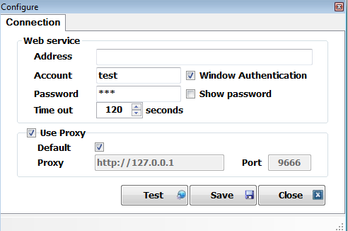

Figure : Configuration window

## Main Window

The main window shows the workspace. In the left hand, there are watch lists, where interested stocks are followed. The main part shows the graphic chart of a stock.



Figure : Main interface of Quantum

## Opening Chart

Right click on the stock on Market Watch list of the left pane. You will see the chart of your stock opened in the right pane.

Here you can work with chart (zoom in, zoom out), working with indicators, or working with Quantum strategies.



Figure : Opening chart

# Account Setting

Go to menu File, then My Profile. You can set up your account information, included portfolio and watch list.

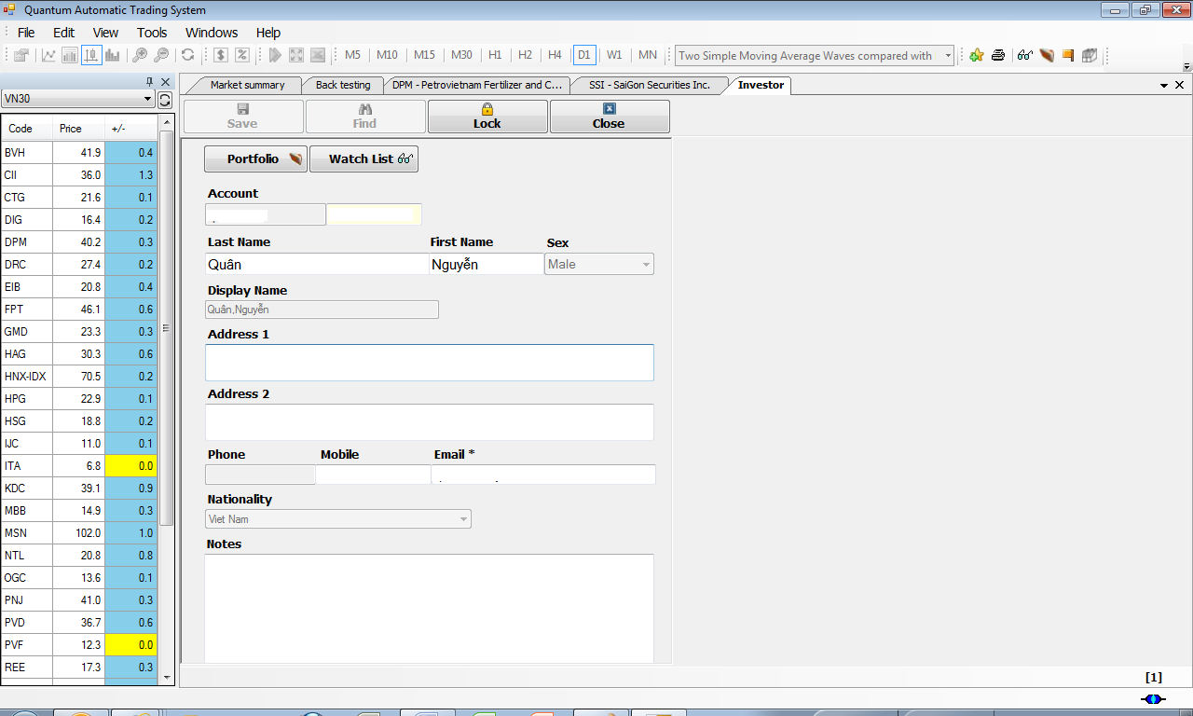

Figure : Account setting

## Creating Portfolio

Click on Portfolio. Set the capital amount of the portfolio.

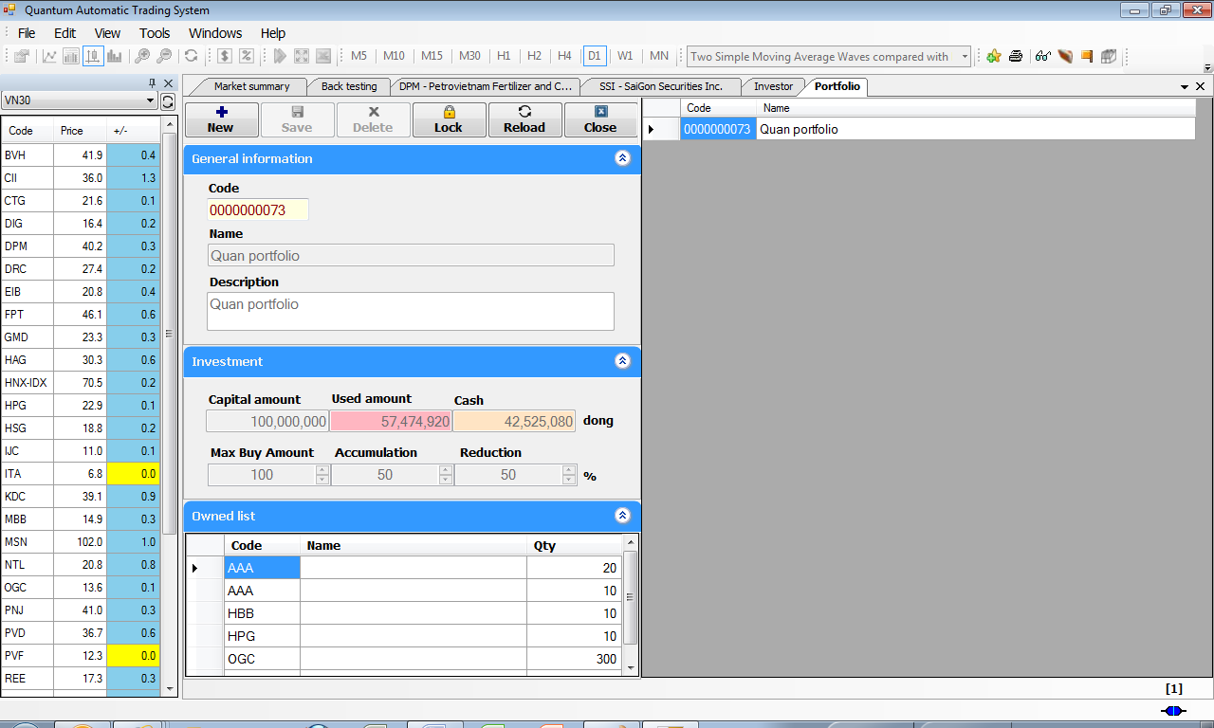

Figure : Portfolio creation

## Creating Watch List

Click on Watch List button. The following window opens. On your right side, there are all of your watch lists. You can create new one by click on “New” button.

You can add new interested stock to your watch list by click on plus button. For every stock, you can add **interested strategies** in order to get alerts when the conditions of the selected strategy satisfy. For every strategy, you have differents time scale : Minutes, Hour, Daily, Monthly. Visit Section , for more information about working with strategy.

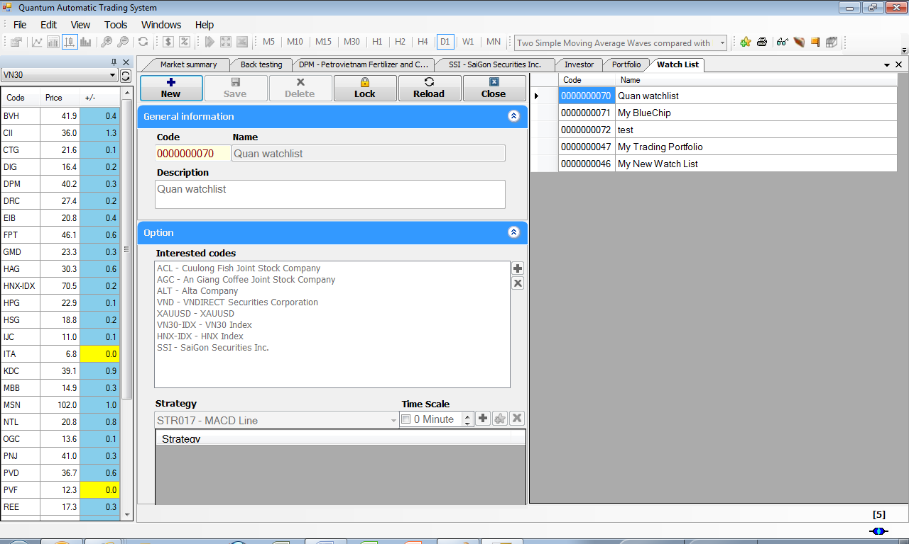

Figure : Watch list customization

# Working with Quantum charts

Chart is the easiest way to know about the stock price. It shows also the historical movement of the stock. Moreover, Quantum Strategy and Quantum Indicators can be presented within a chart.

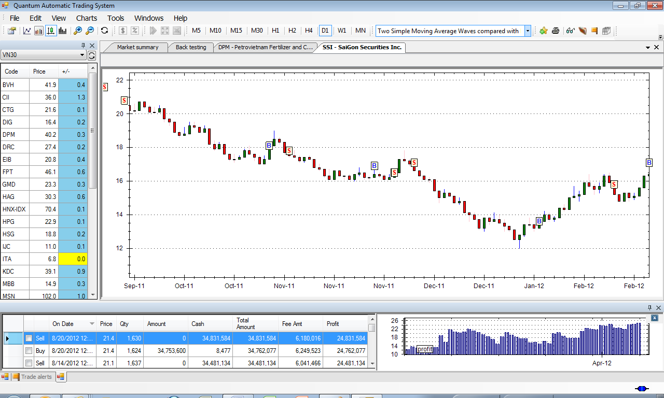

Figure : Stock chart

## Zoom In

Zoom In is the function to zoom in the graphical representation of a stock.

## Zoom Out

Zoom Out is the function to zoom out the graphical representation of a stock.

## Periodicity

There are 9 modes:

* M5: : data will be displayed every 5 minutes
* M10: data will be displayed every 10 minutes
* M15: data will be displayed every 15 minutes
* M30: data will be displayed every 30 minutes
* H1: data will be displayed every hour
* H2: data will be displayed every two hours
* H2: data will be displayed every four hours
* D1: data will be displayed every day
* MN: data will be displayed every month

## Chart Styles

Quantum supports three styles: Line, Bar, and Candlestick.

## Chart Property

Change chart colors and properties by Chart-> Chart Property

## Indicators

Right click -> Indicator -> choose a appropriate indicators.

Refer to Section ,Analyze stocks from scratch with Quantum Technical Indicators for information.

# Decision making with Quantum Strategies

Working with Quantum Strategies is very easy. On the application tool bar, select one from more than 50 automatic strategies. When selecting a strategy, Quantum will apply this strategy and detect the buy/sell points.

This section introduces how to work with Quantum Strategy to get the highest performance for trading.

## Quantum Strategy Overview

### What is a Quantum Strategy (QS)?

A strategy is a computer trading algorithm, which detects automatically when to BUY and when to SELL a securtity (a stock, forex pair, or commodities). It defines how to react when market condition changes.

### How does a Quantum Strategy work ?

A Quantum Strategy analyzes many public information, included the market data, stock price volatility, supply and demand of trading transactions, the volume of the market and the stock. Every Quantum Strategy can be backtested in order to know about its probability of success.

Quantum Strategy Algorithm is defined by our experts and analyzed beforehand about its performance. We can compare differents strategy among with Buy&Hold strategy. In most of the case, the Quantum Strategies outperform the Buy&Hold strategy.

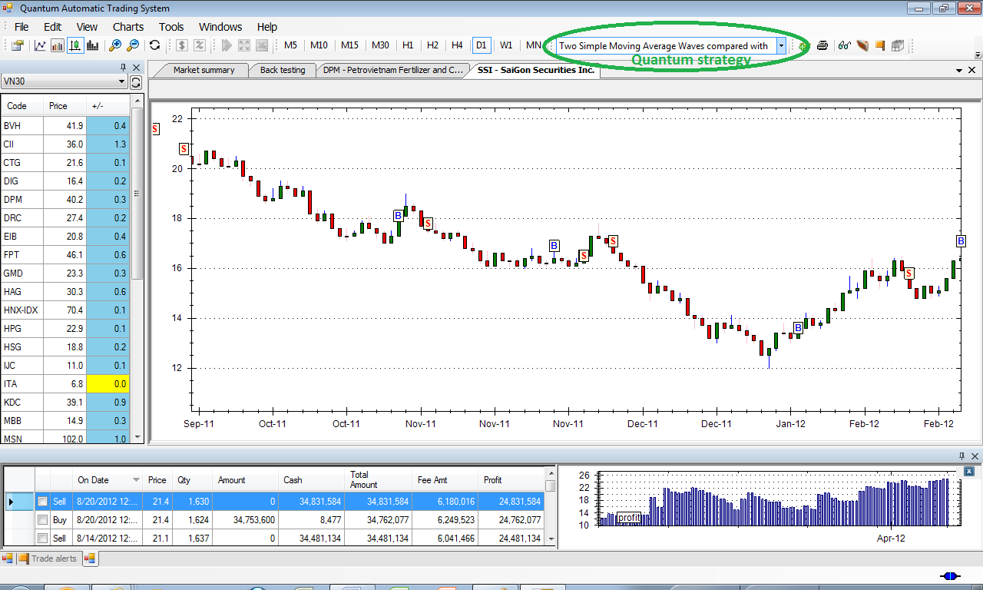

Figure : Quantum strategy

In the moment of this User Guide, there are more than 50 predefined Quantum Strategies. Many others high performance strategies will be added by our experts.

After opening a stock chart, you select a Quantum Strategy in the top right-hand combox box. You can get immediately the results of the Buy/Sell decisions applied to historical stock chart. There are two more windows:

* **Transaction window**: shows all historic buy, sell decision as well as the profit if we trade follow this strategy (the beginning capital is set by defeault VND10million and can be customized in Tools->Preferences->Investment).
* **Performance Evaluation window**: graphic representation of the profit.

### Quantum Strategy parameters

Every Quantum Strategy has different parameters.

* Time Scale: A Quantum Strategy is diffrents following timing we chose for that Strategy. There are Hourly (H1), Daily (D1), Weekly (W1)
* Others specific parameters: go to Tools->Strategy

# Avoiding investment risks with Quantum Back Testing

## What is Quantum Back testing ?

Quantum Backtesting is the process of evaluating a Quantum strategy by applying it to historical data. Backtesting studies how a trading method would have performed in past stock markets. The backtest process replicates the conditions of the past time in order to calculate the performance.

## Why should we back-test ?

Backtesting is a common and methodologically accepted approach to research. Backtesting helps us to test a strategy with a historical data to know if that strategy would work or not.

However a high or successful correlation between a backtested strategy and historical results can never prove a theory correct, since past results do not necessarily indicate future results. In other words, things are always changing, but in a world where yesterday bears some resemblance to today, backtesting can be a useful tool of analysis and prediction.

## How to use BackTesting

Go to Tools->BackTesting. The following window is opened. There are four parts that users should select

* Strategy list: list of pre-defined Quantum strategies.
* Stock code list: list of stocks that will be back tested.
* Periodicity: the time period that we want to backtest
* Strategy time scale: Day/Week/ or Hour.

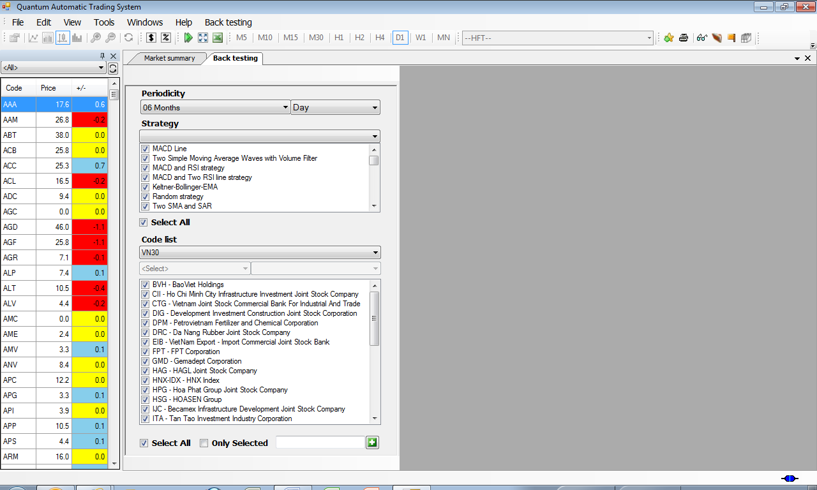

Figure : Back testing functionality

The following window shows Back Testing Result. The result is shown in the grid. The cell in the grid represents the profit/loss for investment during a time period. The beginning amount of capital is set at VND 10mil.

Users can compare the performance of different stocks following one or many strategies.

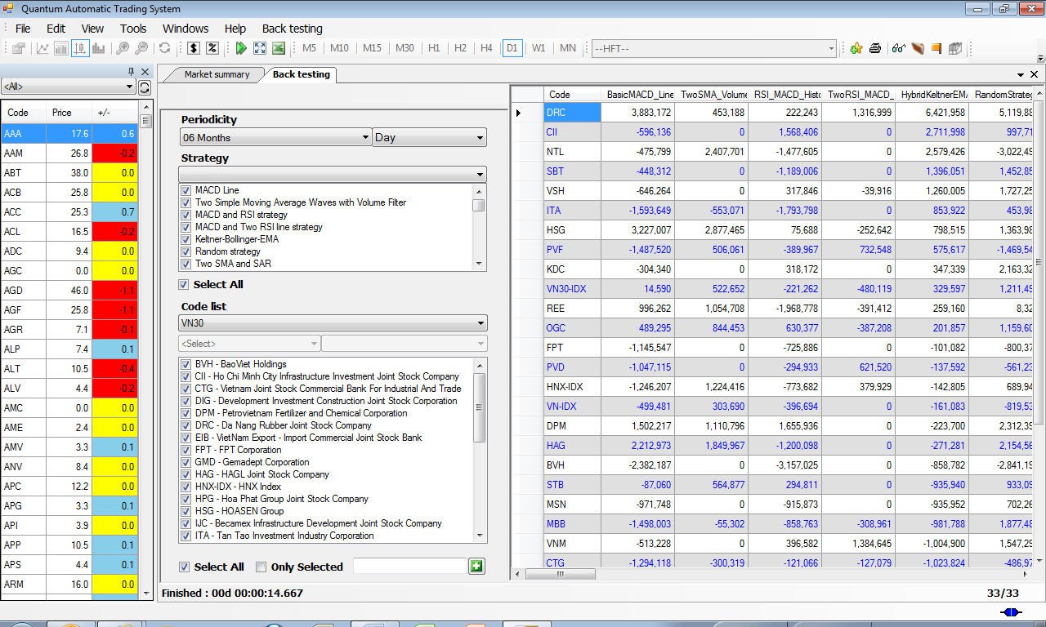

Figure : Back testing result

## Estimation of strategies

In the menu Back Testing, choose Estimation. The Estimation function calculates the following statistics about every strategy:

* The winning percentage
* The lost percentage
* The maximum winning amount
* The maximum lost
* The average winning amount
* The average lost amount

With this estimation, we can find the best performer stock with the best strategy.

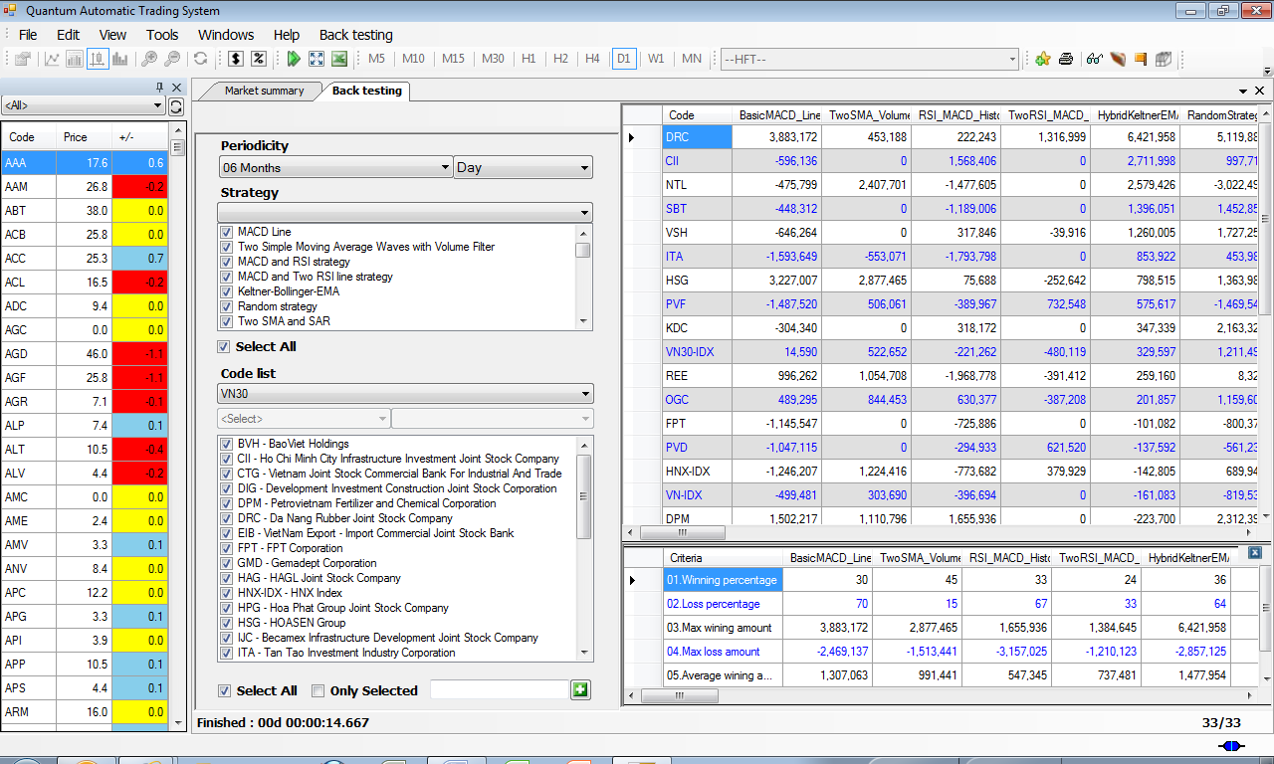Figure : Back testing result

# Finding the best automatic expert with Quantum Strategy ranking

## What is Quantum Strategy Ranking

Quantum Strategy Ranking is a powerful tool to find the best-fit Strategy for a stock.

Every stock has different supply-demand force which influences the volatility. More over, the financial situation of the company affects the price change. So, finding appropriate strategy is the key to success.

Go to Tools-> Strategy Ranking. The following window is shown. There are four options when applying Strategy Ranking

* In the Periodicity box, we can choose the period for testing.
* Time Scale is by default Day. We can choose Week or Month also. That means the Strategy will apply to Daily data or Weekly data.
* Strategy: there are strategies listed by categories. When selecting strategies, they will be ranked for the performance.
* Code list: shows the stocks we want to rank.

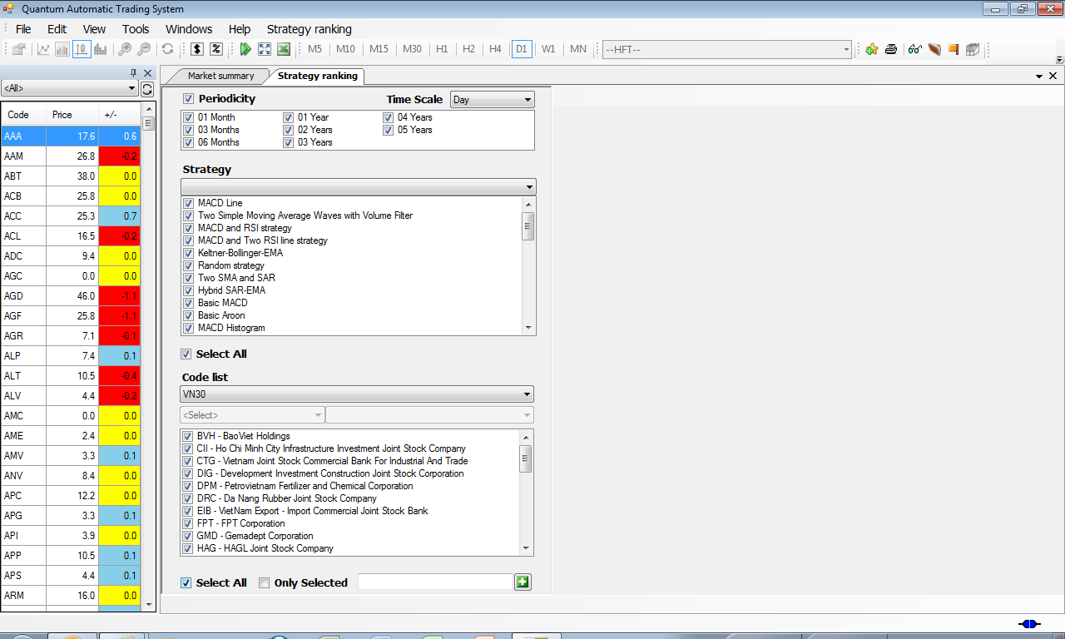

Figure : Quantum strategy ranking

## Strategy Ranking result

In the following window, the result shown on the right window.

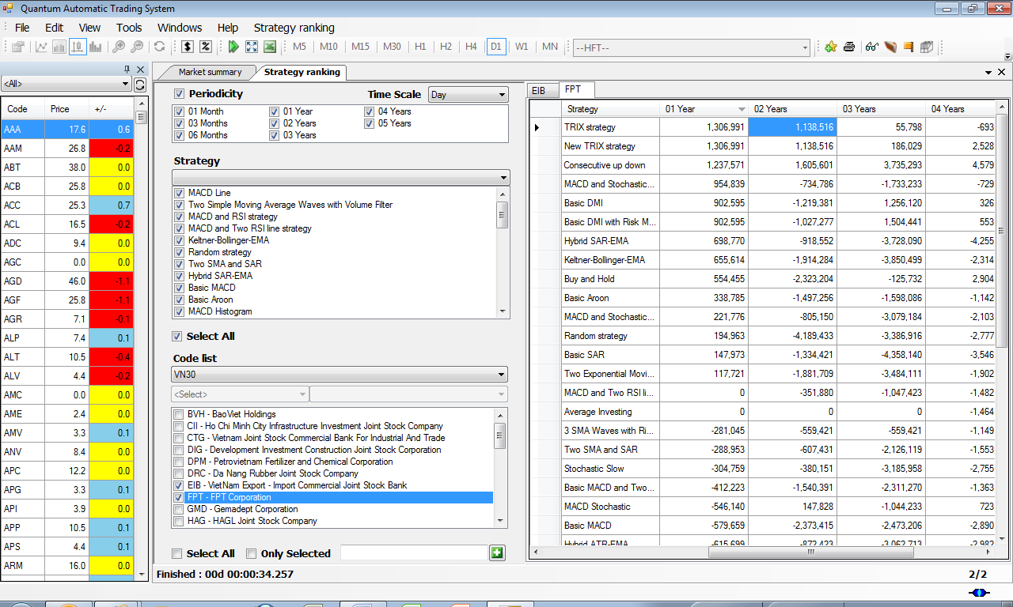

Figure : Quantum strategy ranking result

# Effective way to build a portfolio with Quantum Stock ranking

## What is stock ranking?

Stock Ranking is the process to find out the stocks satisfied some criteria. The Ranking process puts the stocks in order to find the good candidate for the portfolio.

The Stock Ranking has some purposes:

* Stock Ranking: sort the stocks following some weights, for selecting in the trading portfolio
* Screening: find out the stock satisfied pre-defined criteria for selecting in the portfolio, without ranking. They include find stocks with the BUY signal, Sell signal, up-trend stocks or down-trend stocks.

To activate the function, go to Tools -> Stock Ranking. There are actually over 40 predefined screening strategies.

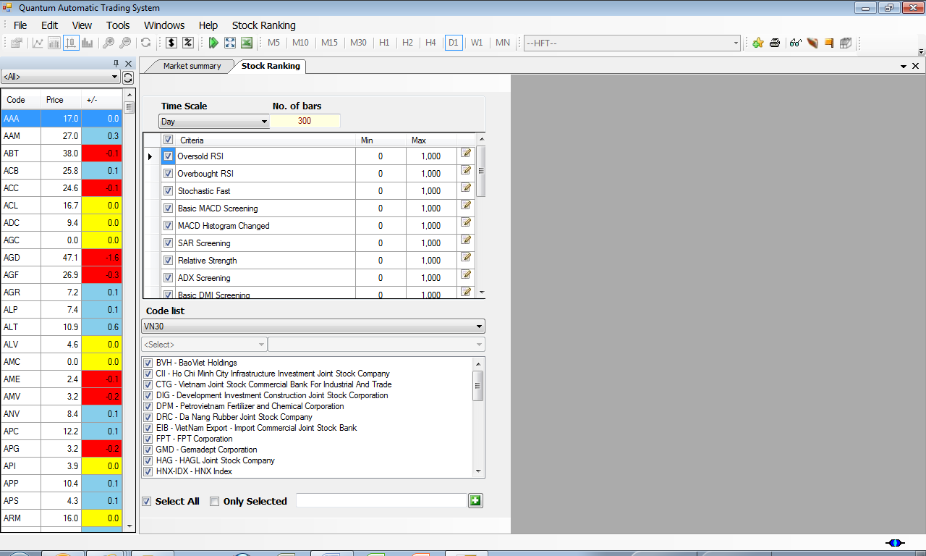

Figure : Stock ranking

## Stock Ranking result

The result is shown in the right window that shows the stocks which satisfy the criteria for selection.

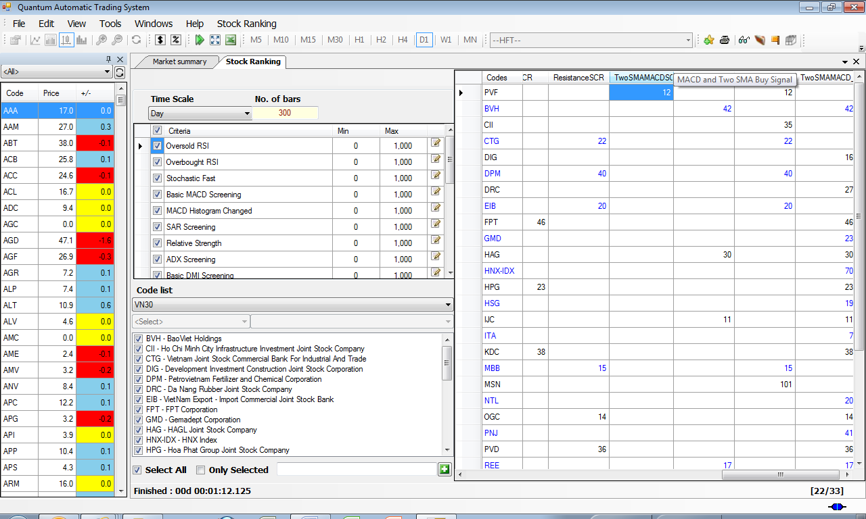

Figure : Stock ranking result

# Analyze stocks from scratch with Quantum Technical Indicators

Quantum provides not only pre-defined algorithm for automatic trading. However, it provides also tools for users who would like to analyze stocks by himself.

Quantum provides more than 70 built-in technical indicators. With those indicators, technicians can analyze stock trends and find out the right moment to take action. With those technical indicators, investors have the same functionality as MetaStock or MetaTrader software.

There are five categories: Trending,Oscilators, Volume, Market, and Customized. Please refer to the Annex for more information about technical indicators.

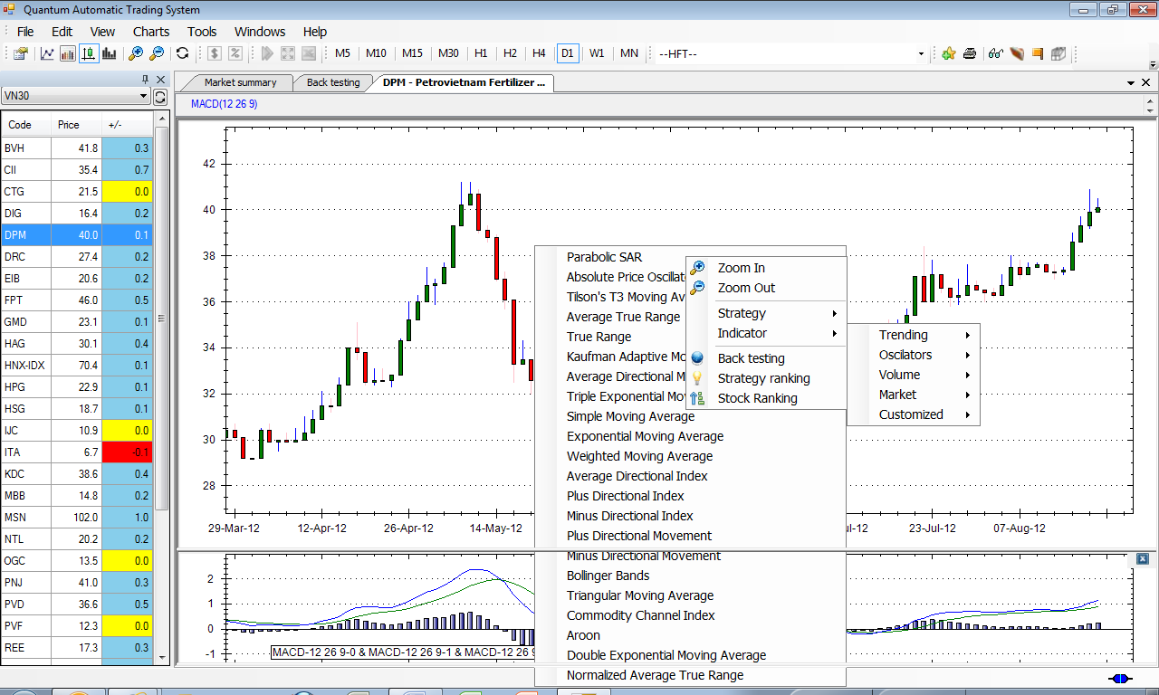

Figure : Choosing indicators

## Indicator parameters

When selecting one indicator, the Indicator parameters window will be shown.

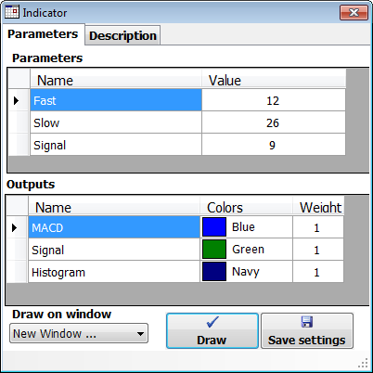

Figure : Indicator parameter window

## Indicator chart

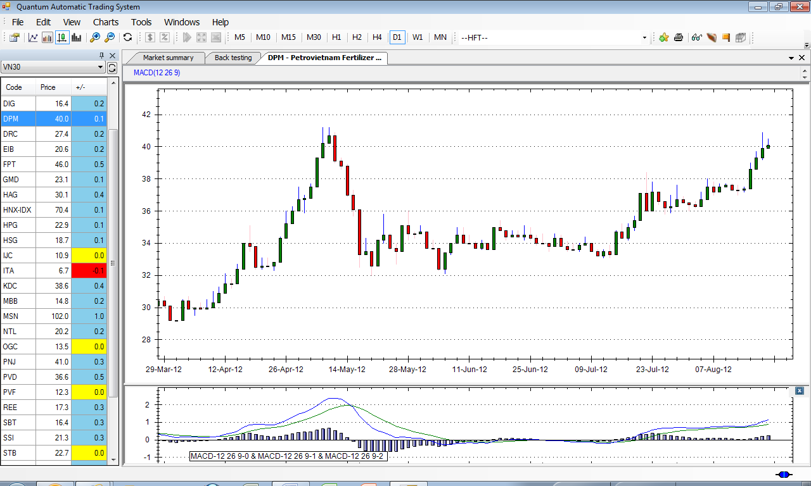

Figure : Chart with MACD indicator

# Alerts for preference stocks

In order to get the alerts for the stocks in Watch List or in Portfolio, choose View -> Trade Alerts.s

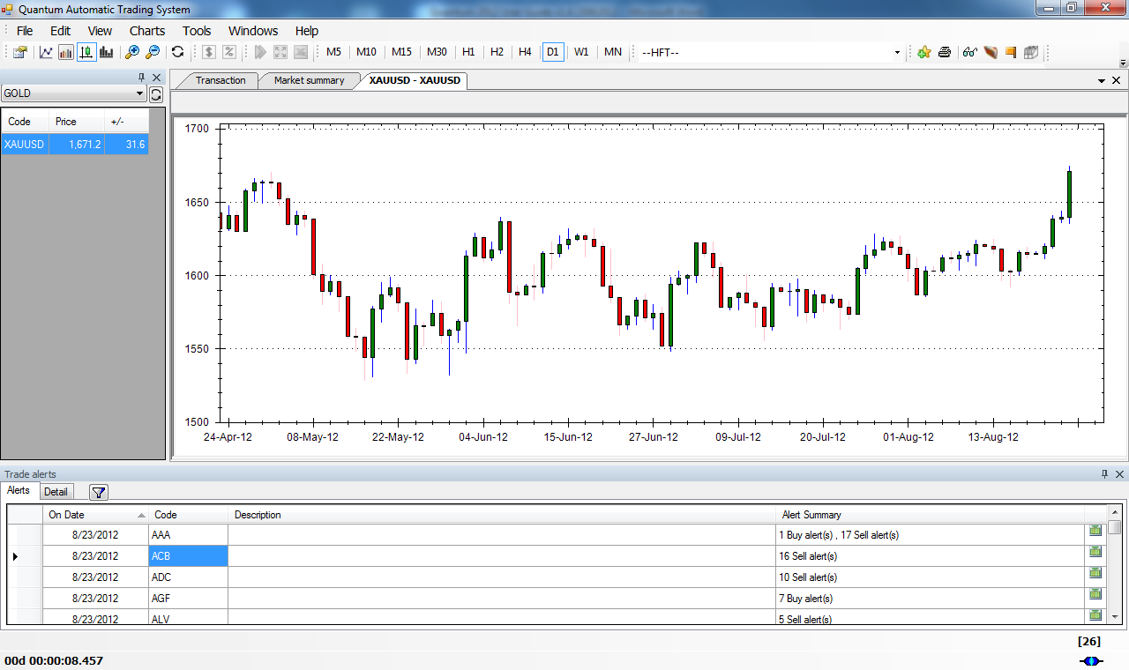

Figure : Alert window

# Portfolio Management

Choose View -> My Portfolio to see the Stocks in our Portfolio.

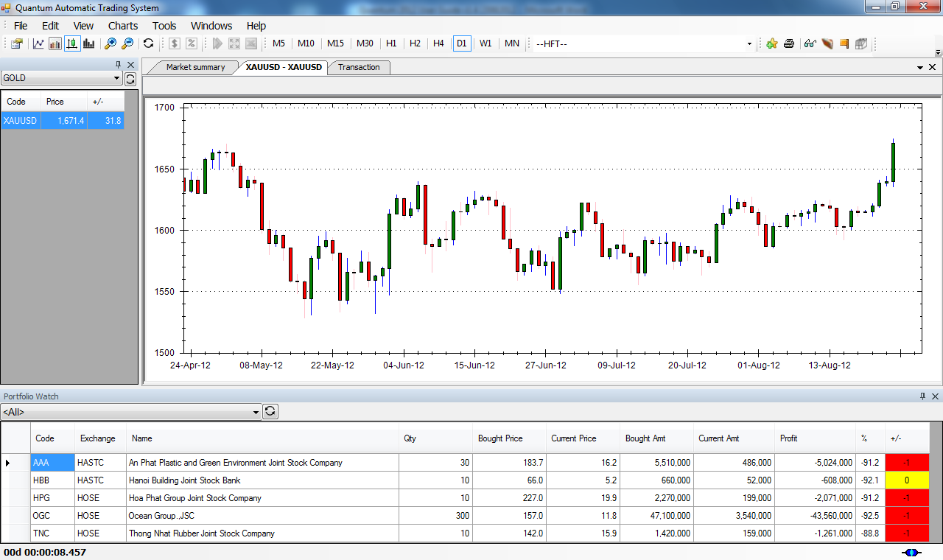

Figure : Portfolio window

In order to make a transaction, you make an order. Go to Tools -> Order.

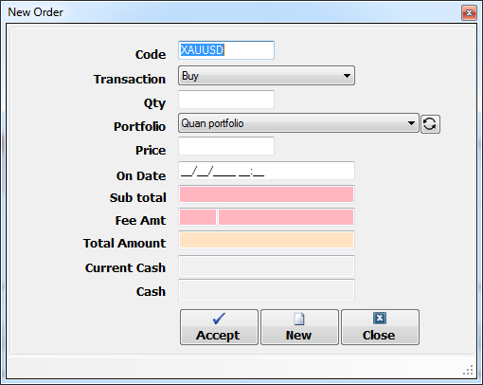

Figure : Order window

# Conclusion

This user guide provides the guidelines for using Quantum Automatic Trading System. The document presents how to deal with charts, using Quantum Strategies, using different tools for evaluating a strategy (Backtesting, Strategy Ranking).

With Quantum, investor can benefit its quantitative model to maximize gains and minimize risks during trading activity.

# Appendix 1: Frequent Asked Question

## Connection problems

* Please check firstly your Internet connection or check the network. Sometimes you need to reboot your computer.
* Check your account name and password. If there is an error, please re-enter.
* Check if you are behind a proxy. If yes, choose “Configuration” button in the login window, and enter the correct proxy information.

If the problems persist, contact your computer administrator.

## What is the performance of Quantum?

Quantum is the integrated solution for trading. It provides powerful algorithm to detect the good time to buy or to sell stock. That means it maximizes your probability to win and minimize your risk. Quantum Strategy beats the performance of VNIndex during last 5 years.

## Can I chose a moment to buy or sell stock ?

Yes. Use Quantum strategy in Section :

## Can I find a good stock to trade ?

Yes. Use Quantum Stock Ranking (ref Section :Effective way to build a portfolio with Quantum Stock ranking)

## How can I find a stock with Buy decision?

Yes. Use Quantum Stock Ranking (ref Section :Effective way to build a portfolio with Quantum Stock ranking). Chose the screening created from Strategy.

# Appendix 2: Glossary

* Indicator: Technical analysis indicator has the purpose of helping to analyze trend of a stock.
* Strategy: Mathematic model to determine Buy or Sell entry point.
* Periodicity: defines timeframe of a specific chart.
* Duration: a period in within a chart is shown.
* Watch List: pre-defined list of stocks that investor wants to follow.
* Portfolio: stocks that an investor own.

# Appendix 3: Quantum Strategy Explanation

## Trending Category

|  |  |  |  |
| --- | --- | --- | --- |
| **Name** | **Parameters** | **Code** | **Description** |
| Buy and Hold |  | BuyAndHold | This strategy defines the transaction with Buy in the beginning period and Sell at the end of the period. Usually, the Buy&Hold strategy is the benchmark for other strategies.  Example: If period is 1 year, then the strategy applies the Buy one year before and the Sell order today |
| Basic DMI | Plus Period=14,  Minus Period=14,  Stop Loss Level (%)=5,  Trailing Stop (%)=15,  Take Profit Level (%)=200 | BasicDMI | This strategy evaluates strength of the trend to find out the best time to enter or exit the market. The strategy includes money management strategy. |
| Basic MACD | MACD Fast=12,MACD Slow=26,MACD Signal=9 | BasicMACD | This strategy evaluate the difference between two moving averages at any time to determine timing to enter the market. This strategy works well for trending market. |
| Stochastic Slow | Fast K=15,  Slow K=5,  Slow D=3,  Ma Type=4 |  | This strategy uses momentum oscillator Slow Stochastic to evaluate timing to enter the market. |
| MACD Histogram | MACD Fast=12,  MACD Slow=26,  MACD Signal=9,  Stop Loss Level (%)=5,  Trailing Stop (%)=10, Take Profit Level (%)=50 |  | MACD strategy using histogram changes |
| MACD Line | MACD Fast=12,  MACD Slow=26,  MACD Signal=9 | BasicMACD_LineCut | MACD using macd and signal line cut |
| Two EMA Volume | Short Period = 5,  Long Period=10,  Stop Loss Level (%)=5,  Trailing Stop (%)=15, Take Profit Level (%)=50 | TwoEMAVolume | Two EMA of Volume cut each others |
| Two Simple Moving Average Waves compared with Price | Short Period = 5,  Long Period=10 | PriceTwoSMA | Two Simple Moving Average Waves compared with Price |
| Three Simple Moving Average Waves | Short Period = 5,  Medium Period=10,  Long Period=20 | Price_3SMA | Three Simple Moving Average Waves |
| 3 SMA Waves with Risk Reward Ratio | Short Period=5,  Medium Period=10,  Long Period=20,  Risk Reward Ratio=2,  Period for Risk Reward Ratio=60 | Price_3SMA_Risk_Reward | Three SMA Waves at Risk Reward Ratio |
| Two Weighted Moving Average Waves | Short Period = 5,  Long Period=10,  Stop Loss Level (%)=5,  Trailing Stop (%)=15, Take Profit Level (%)=50 | TwoWMA | Two Weighted Moving Average Waves |
| Two Exponential Moving Average Waves | Short Period = 5,  Long Period=10,  Stop Loss Level (%)=5,  Trailing Stop (%)=15, Take Profit Level (%)=50 | TwoEMA | Two Exponential Moving Average Waves |
| Two Simple Moving Average Waves | Short Period = 5,  Long Period=10,  Stop Loss Level (%)=5,  Trailing Stop (%)=15,  Take Profit Level (%)=50 | TwoSMA | Two Simple Moving Average Waves |
| Two Simple Moving Average Waves with Volume Filter | Short Period=5,  Long Period=10,  Volume Filter=100000,  Stop Loss Level (%)=5,  Trailing Stop (%)=15,  Take Profit Level (%)=50 | TwoSMA_VolumeFilter | Two Simple Moving Average Waves with Volume Filter |
| Basic SAR | AF=0.02,Step=0.2,Stop Loss Level (%)=5,Take Profit Level (%)=200 | BasicSAR | Buy when price above SAR line |
| Basic ATR | ATR Period=14,  Stop Loss Level (%)=5,  Take Profit Level (%)=200 | BasicATR | Basic ATR |
| Stochastic RSI | RSI=14,Fast K=14,Fast D = 9,Stop Loss Level (%)=5,Trailing Stop (%)=15, Take Profit Level (%)=50 | BasicStochRSI | Buy when cut between line K and D in Stochastic RSI |

## High Frequency Trading category

|  |  |  |  |
| --- | --- | --- | --- |
| **Name** | **Parameters** | **Code** | **Description** |
| SMA Stochastic | Short SMA=5,  Long SMA=10,  Fast K=15,  Slow K=5,  Slow D=3,  Ma Type=4 | SMA_Stochastic | Buy and sell condition following Stochastic Slow and Two SMA |
| MACD and ADX | MACD Fast=12,  MACD Slow=26,  MACD Signal=9,  ADX Period=14,  Stop Loss Level (%)=5,  Trailing Stop (%)=15,  Take Profit Level (%)=100 | MACD_ADX | Buy when there is cut between signal and macd line |
| MACD Stochastic | Simple moving average=20,  MACD Fast=12,  MACD Slow=26,  MACD Signal=9,  Fast K Period=15,  Slow K Period=5,  Slow D Period=3,  Ma Type=4 | MACD_Stochastic | Buy when there are differences in MACD signal and MACD lines, with Stochastic line K above D, and in up trend (defined by SMA condition) |
| MACD and Stochastic Extension | Simple moving average=20,MACD Fast=12,MACD Slow=26,MACD Signal=9,Fast K Period=15,Slow K Period=5,Slow D Period=3,Ma Type=4 | MACD_Stochastic_Bottom |  |
| MACD and Stochastic Extension v1 | Simple moving average=20,MACD Fast=12,MACD Slow=26,MACD Signal=9,Fast K Period=15,Slow K Period=5,Slow D Period=3,Ma Type=4 | MACD_Stochastic_Bottom_v1 | Buy when there are differences in MACD signal and MACD lines, with Stochastic line K above D, and in up trend (defined by SMA condition) and Stochastic Slow K below 70 |
| MACD and RSI strategy | MACD Fast=12,MACD Slow=26,MACD Signal=9, RSI Period=14, RSI Over Sold=30, RSI Over Bought=70,Stop Loss Level (%)=5,Take Profit Level (%)=200 | RSI_MACD_Histogram | MACD and RSI strategy |
| MACD and Two RSI line strategy | MACD Fast=12,MACD Slow=26,MACD Signal=9, RSI Period=14, RSI Over Sold=30, RSI Over Bought=70,Stop Loss Level (%)=5,Take Profit Level (%)=200 | TwoRSI_MACD_Histogram | MACD and RSI strategy |
| Two SMA and SAR | AF=0.02,Step=0.2,Short Period=5,Long Period=10,Stop Loss Level (%)=5,Take Profit Level (%)=200 | TwoSMA_SAR | Buy when price above SAR line |
| Time Series and Linear Regression | Time Series Period=25,Linear Regression Period=25,Stop Loss Level (%)=5,Take Profit Level (%)=200 | TSFLIN | Time Series and Linear Regression |
| TRIX strategy | Period=25,Stop Loss Level (%)=5,Take Profit Level (%)=200 | BasicTRIX | TRIX strategy |
| New TRIX strategy | Period=25,Stop Loss Level (%)=5,Trailing Stop (%)=15, Take Profit Level (%)=200 | BasicTRIX_Trailing | New TRIX strategy |
| Two Line TRIX strategy | Short Period=10,Long Period=30,Stop Loss Level (%)=5, Take Profit Level (%)=200 | TwoLineTRIX | Two Line TRIX strategy |
| Hybrid SAR-EMA | AF=0.02,Step=0.2,Short Period=5,Long Period=10,Stop Loss Level (%)=5,Take Profit Level (%)=200 | EMASAR | Buy when price above SAR line and EMA short period cut EMA long period |
| Hybrid ATR-EMA | ATR Period=14,EMA Short Period=5,EMA Long Period=10,Stop Loss Level (%)=5,Trailing Stop (%)=15, Take Profit Level (%)=200 | HybridEMAATR | Hybrid ATR-EMA |
| Hybrid ATR-SMA | ATR Period=14,SMA Short Period=5,SMA Long Period=10,Stop Loss Level (%)=5,Trailing Stop (%)=15, Take Profit Level (%)=200 | HybridSMAATR | Hybrid ATR-SMA |
| Hybrid ATR-MACD Histogram | ATR Period=14,MACD Fast=12,MACD Slow=26,MACD Signal=9,ADX Period=14,Stop Loss Level (%)=5,Trailing Stop (%)=15, Take Profit Level (%)=200 | HybridMACDHistATR | Hybrid ATR-MACD Histogram |
| Keltner-Bollinger-EMA | Bolliger Period=20,  k Up = 2,  k Down = 2,  EMA Period=20,  ATR Multiplier=2.0,  ATR Period=10,  EMA Short Period=5,  EMA Long Period=10,  Stop Loss Level (%)=5,  Trailing Stop (%)=15,  Take Profit Level (%)=200 | HybridKeltnerEMA | Keltner-Bollinger-EMA |
| ATR-Parabolic SAR | ATR Period=14,AF=0.02,Step=0.2,Stop Loss Level (%)=5,Trailing Stop (%)=15, Take Profit Level (%)=200 | HybridSARATR | ATR-Parabolic SAR |
| ATR-Parabolic SAR-ADX | ATR Period=14,AF=0.02,Step=0.2,ADX Period=14,Stop Loss Level (%)=5,Trailing Stop (%)=15, Take Profit Level (%)=200 | HybridSarAtrAdx | ATR-Parabolic SAR-ADX |
| Basic MACD and Two SMA cut | MACD Fast=12,MACD Slow=26,MACD Signal=9,Short Period=5,Long Period=10,Stop Loss Level (%)=5,Trailing Stop (%)=15, Take Profit Level (%)=50 | TwoSMABasicMACD | Screen sell signal for stock macd line below 0 and Short term SMA is below Long term SMA |
| MACD and StochSlow | Simple moving average=20,MACD Fast=12,MACD Slow=26,MACD Signal=9,Fast K Period=15,Slow K Period=5,Slow D Period=3,Ma Type=4 | MACD_StochSlow | Buy when there are differences in MACD signal and MACD lines, with Stochastic line K above D, and in up trend (defined by SMA condition) |

## Others

|  |  |  |  |
| --- | --- | --- | --- |
| **Name** | **Parameters** | **Code** | **Description** |
| Average Investing | Period = 30, Buy Level from Average(%) = 20,Sell Level from Average(%) = 15,Stop Loss Level (%)=4,Take Profit Level (%)=200 | AverageStrategy | Buy when price down to Buy Level, Sell when price up to Sell Level |

# Appendix 4: Quantum ranking

## Buy Signal Category

Here is the screening strategy for selecting the stocks which have BUY signal for today trading.

|  |  |  |  |
| --- | --- | --- | --- |
| **Name** | **Parameters** | **Code** | **Description** |
| MACD and Two SMA Buy Signal | MACD Fast=12,  MACD Slow=26,  MACD Signal=9,  Short Period=5,  Long Period=10 | TWOSMAMACDSCR | This stock ranking finds stocks that has BUY signal when conditions are satisfied by two strategy: BasicMACD and TwoSMA. Two technical indicators are used is MACD line, and crossover over of 5 days Moving Average and 10 days Moving Average. |
| Two SMA Buy Signal | Short Period=5,Long Period=10 | TwoSMASCR | This stock ranking finds stocks that has BUY signal when two SMA lines cut each others |
| MACD Histogram Changed | MACD Fast=12,  MACD Slow=26,  MACD Signal=9 | MACD_HistogramSCR | Finding Buy Signal from MACD Histogram Strategy |
| Stochastic Fast | Fast K=14,  Fast D=3 | StochFastSCR | Finding Stocks with BUY signal from StochFast Strategy |
| Basic MACD | MACD Fast=12,  MACD Slow=26,  MACD Signal=9 | BasicMACDSCR | Screen stock with MACD above 0 |
| Basic DMI | Plus Period=14,  Minus Period=14 | BasicDMISCR | Screen stock with DI+ above DI- |
| SAR Screening | AF=0.02,  Step=0.2 | BasicSARSCR | Finding stocks with Buy Signal from BasicSAR strategy |

## Sell Signal Category

|  |  |  |  |
| --- | --- | --- | --- |
| **Name** | **Parameters** | **Code** | **Description** |
| MACD and Two SMA Sell Signal | MACD Fast=12,  MACD Slow=26,  MACD Signal=9,  Short Period=5,  Long Period=10 | TwoSMAMACD_SELL | Screen sell signal for stock macd line below 0 and Short term SMA is below Long term SMA |

## Up Trend Category

|  |  |  |  |
| --- | --- | --- | --- |
| **Name** | **Parameters** | **Code** | **Description** |
| Uptrend Price | SMA Period=20 | PriceSCR | Screen stock with price above SMA lines with Period as parameter |
| MACD and Two SMA Up Trend | MACD Fast=12,  MACD Slow=26,  MACD Signal=9,  Short Period=5,  Long Period=10 | TwoSMAMACD_UPTREND | Screen Up Trend for stock macd line below 0 and Short term SMA is below Long term SMA |

## Down Trend Category

|  |  |  |  |
| --- | --- | --- | --- |
| **Name** | **Parameters** | **Code** | **Description** |
| MACD and Two SMA Down Trend | MACD Fast=12,  MACD Slow=26,  MACD Signal=9,  Short Period=5,  Long Period=10 | TwoSMAMACD_DOWNTREND | Screen Down Trend stocks having MACD line below 0 and Short term SMA is below Long term SMA |

## Other category

Those screenings are used for portolio selection.

|  |  |  |  |
| --- | --- | --- | --- |
| **Name** | **Parameters** | **Code** | **Description** |
| ADX Screening | ADX Period=14 | BasicADXSCR | Finding stocks that has trend (Up trend, or Downtrend). This screening is based on ADX technical indicator. |
| Volume of the last day in a range |  | BasicVolumeSCR | Volume of the last day in a range |
| Volume Screening |  | VolumeSCR | Volume of the last day above volume of the previous day |
| Price change (%) |  | PriceChangeSCR | Price change (%) |
| Relative Strength |  | RelativeStrengthSCR | Find the best perform stocks |
| Stocks near support | Period=30,  Distance (%)=1 | SupportSCR | Find stocks near support line |
| Stocks near resistance | Period=30,  Distance (%)=1 | ResistanceSCR | Finding Stocks near Resistance Line |
| Abnormalies Screening | Period=30,  Multi=2 |  | Finding stocks which have abnormaly behaviour |
| Basic Price Screening |  | BasicPriceSCR | Screen stock with target price |

# Appendix 5: Quantum technical indicators

## Trending Indicators Category

We introduce here some frequent technical indicators. Other indicators are explained in our website.

### Simple Moving Average

A simple moving average is a trending indicator that eliminates the volatility of daily price movement and smoothes it out into a line that is plotted on top of the price movement of a security. As with all other technical indicators, a simple moving average is based on past price data and thus lags current price movement, but the information it provides is incredibly beneficial.

You can add up to three simple moving averages on your chart, and you can customize the time frame for each one. For example, if you decided to plot three simple moving averages on your chart, you could select time frames of 30, 50, and 200. That means the first moving average would average out the price movement for the past 30 time periods, the second moving average would average out the price movement for the past 50 periods, and the last moving average would average out the price movement for the past 200 periods.

Using moving averages is the easiest way to determine the trend of a security. If the moving average is pointing up, the security is trending higher. If the moving average is pointing down, the security is trending lower. Of course, the time frame of the moving average determines how responsive, or volatile, the moving average is going to be.

A shorter-term moving average—such as the 30-period simple moving average—is going to be much more responsive than a longer-term moving average—such as the 200-period simple moving average. You can see this in the AAPL chart where the red, 30-period simple moving average moves more than the green, 200-period simple moving average. Looking at this chart, the shorter-term 30-period simple moving average is trending lower while the longer-term 200-period moving average is tending higher.

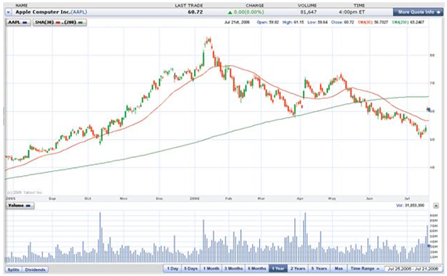

### Exponential Moving Average

An exponential moving average is a trending indicator that, like a simple moving average, eliminates the volatility of daily price movement and smoothes it out into a line that is plotted on top of the price movement of a security. The difference between exponential moving averages and simple moving averages, though, is exponential moving averages place more weight on the most recent data while simple moving averages weight all data equally.

You can see the difference this weighting makes, especially on the 200-period moving average, as you look at the Apple Computers (AAPL) chart. Simply by changing from a simple moving average to an exponential moving average, the longer-term 200-period moving average is now trending lower, not higher as it was when using a simple moving average.

When deciding whether to use an exponential moving average or a simple moving average, you need to ask yourself how aggressive you want to be in your investing. Aggressive investors are better suited for an exponential moving average because of its increased volatility while less aggressive investors are better suited for a simple moving average.

Whether you decide to use simple or exponential moving averages or long- or short-term time frames, you should always try to trade with the trend of the security you are analyzing

### Weighted Moving Average

The Weighted Moving Average indicator calculates the average of a set of values over a specified period.

### Average Directional Index

The Directional Movement Index consists of Average Directional Index, or ADX, which defines the strength of the trend; DI+ and DI, which demonstrate the strength of the decreasing and increasing prices correspondingly.

### Bollinger Bands

Bollinger bands form an envelope that expands and contracts around a simple moving average. The expansion of the bands is based on the volatility of the equity. As the equity becomes more volatile, the bands expand. As the equity becomes less volatile, the bands contract.

The default setting for Bollinger bands is 20 and 2, which means the indicator takes the past 20 time periods into account and bases its calculations based on two standard deviations from the mean. You will most likely want to leave the default unchanged when you plot this indicator.

Also, when you plot Bollinger bands on your chart, you should also plot a 20-period simple moving average so you can visualize the simple moving average the Bollinger bands are interacting with.

Many investors will use Bollinger bands to judge the magnitude of a stock movement and identify moments when the trend of the simple moving average may be coming to an end. For example, if you see the two Bollinger bands dramatically spread apart and start moving in opposite directions, you know the stock has just made a dramatic move. For a clue as to when that move may end you can keep an eye on the Bollinger band that is moving in the same direction as the price. When this band starts to turn around and converge with the other band—as it did in mid-February on Apple Computers (AAPL)—you know the current price movement is losing momentum.

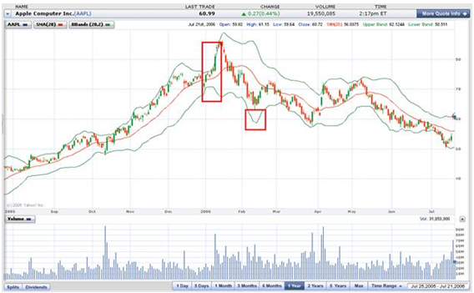

### Parabolic SAR

Parabolic S-A-R is a trending indicator that can help you determine when to exit a trade. S-A-R stands for “stop and reverse,” and when you see the price hit the parabolic S-A-R indicator on the chart, you may want to consider exiting your trade. You can look at is as a type of technical stop loss for your trades.

Again, as with Bollinger bands, you will most likely want to leave the default settings alone when plotting this indicator. Here’s how it works. The parabolic S-A-R, after if reverses from either above or below the price on the chart will slowly start to tighten up and move in closer and closer to the price until the price ultimately hits the indicator. This causes the indicator to flip over to the other side of the price and begin the process all over again.

If you use the parabolic S-A-R as a stop loss indicator, you know you will never hold onto a trade that goes against you because it will tell you when to exit. However, it does have its limitations. It may take you out of trades that are only experiencing a momentary pull back before they continue on to higher and higher profits, as it did in November on the Apple Computers (AAPL) chart.

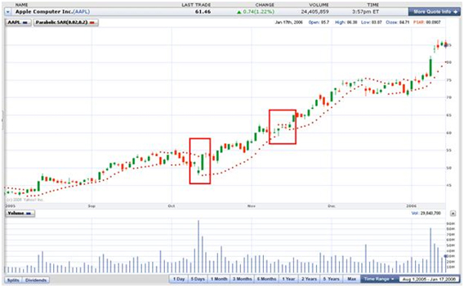

### Average True Range

Developed by J. Welles Wilder, the Average True Range (ATR) is an indicator that measures volatility

### Aroon

Developed by Tushar Chande in 1995, Aroon is an indicator system that determines whether a stock is trending or not and how strong the trend is. The indicators are designed to reveal the beginning of a new trend.

### Commodity Channel Index

Developed by Donald Lambert and featured in Commodities magazine in 1980, the Commodity Channel Index (CCI) is a versatile indicator that can be used to identify a new trend or warn of extreme conditions. Lambert originally developed CCI to identify cyclical turns in commodities, but the indicator can successfully applied to indices, ETFs, stocks and other securities.

## Oscilators Category

### Relative Strength Index

RSI indicator compares the average of up and down closes for a specific period of time.

### Moving Average Convergence/Divergence

MACD calculates and displays the difference between the two moving averages at any time.

### Average Directional Index, Plus Directional Index, Minus Directional Index

The Directional Movement Index consists of Average Directional Index, or ADX, which defines the strength of the trend; DI+ and DI, which demonstrate the strength of the decreasing and increasing prices correspondingly.

### Stochastic RSI

Combining RSI with Stochastic.

### Fast Stochastic

Stochastic is a momentum oscillator, which consists of two lines: %K - fast line, and %D - slow line. Stochastic is plotted on the scale between 1 and 100.

### Accumulation/Distribution Oscillator

Developed by Marc Chaikin, the Chaikin Oscillator measures the momentum of the Accumulation Distribution Line using the MACD formula. This makes it an indicator of an indicator. The Chaikin Oscillator is the difference between the 3-day EMA of the Accumulation Distribution Line and the 10-day EMA of the Accumulation Distribution Line.

### Aroon Oscillator

Developed by Tushar Chande in 1995, Aroon is an indicator system that determines whether a stock is trending or not and how strong the trend is. The indicators are designed to reveal the beginning of a new trend.

### Chande Momentum

The Chande Momentum Oscillator (CMO) was developed by Tushar Chande who is a scientist, and respected trading system developer. Mr. Chande developed the Chande Momentum Oscillator to capture what he calls “pure momentum”.

## Volume

### Accumulation/Distribution

The Accumulation/Distribution Line was developed by Marc Chaikin to measure the cumulative flow of money into and out of an index or security.

## Market

## Customized

### Balance of Power

Balance of Power has been added to Investor/RT, both for charting and for use in scans, custom indicators, and signals (token BOP). The Investor/RT implementation of the BOP is based on an article by Igor Livshin that can be found on p. 18 of the August 2001 issue of Stocks and Commodities Magazine.

### Linear Regression

In statistics, linear regression is an approach to modeling the relationship between a scalar variable y and one or more variables denoted X. In linear regression, data are modeled using linear functions, and unknown model parameters are estimated from the data. Such models are called linear models.